

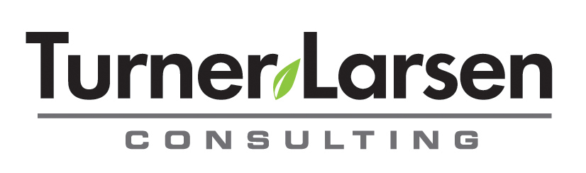

Workshop Registration Form - Personal Excellence for Women

Date:
Name of Registrant:
Organization: Position:
Email: Work Phone:
Work Fax:
Workshop Date: Workshop Location:
Type of Payment: Cheque __ Credit Card __(Payment by credit card is through PayPal only. You do not require a PayPal account. An email will be forwarded to you.)

I have read and agree to the cancellation policy below: _____yes _____no
Registration Agreement Registration – Complete registration form and submit by fax (306-789-2056 or email w.tl@sasktel.net). Be sure to read the cancellation policy and sign this form. Confirmation of your registration will be emailed back to you along with workshop information and attached invoice. If you are paying by credit card, instructions will also be emailed to you to complete the transaction.
- Registration fee of $895.00 + gst needs to be paid in full 2 weeks following your email registration.
- If paying by cheque, send payment to:
Turner Larsen Consulting Wendy Turner-Larsen 338 University Park, PO Box 21028 Gardiner Park Regina, SK S4V 1J4
- Make cheques payable to: Turner Larsen Consulting
Cancellation Policy:
Following confirmation of your registration by email, if you wish to cancel, you may do so by contacting Wendy Turner-Larsen by email. There will be a $150.00 fee charged for canceling your registration prior to one week before the workshop starts (the registration deadline). If you wish, you can transfer your registration to someone else if you notify Wendy of the change prior to the registration deadline at 5 pm. If you choose to cancel after the registration deadline, there will be no refund and your registration is not transferable. If you wish to transfer your registration to another workshop, there will be a $50.00 charge. If cancellation is due to illness or medical emergency, your workshop cost will be refunded to you in full.
_________________________________________________
Signed by Registrant Email to w.tl@sasktel.net or Fax to 306-789-2056
Wendy Turner-Larsen

Thank you for your interest in my services. Wendy Turner-Larsen M.A. Counseling/Psychology; M.A. Adult Education M.S. Health & Nutrition Education

Sincerely,
Wendy Turner-Larsen

